Payer and Payee
# Source: AI Source: Provided by: [Data Path: Persons Table -> ID Column: 1, Name_En Column: Motasem Essam] -> From: [ChatGPT] on [1/21/2026]
In any payment system, the most fundamental actors are the Payer and the Payee. These are the two parties involved in initiating and receiving a payment.

🧍‍♂️ Payer (Sender)
# Source: AI Source: Provided by: [Data Path: Persons Table -> ID Column: 1, Name_En Column: Motasem Essam] -> From: [ChatGPT] on [1/21/2026]
The Payer is the person or entity who initiates the payment — in other words, the one who is paying the money.

🔑 Key Points:
# Source: AI Source: Provided by: [Data Path: Persons Table -> ID Column: 1, Name_En Column: Motasem Essam] -> From: [ChatGPT] on [1/21/2026]
- Typically a customer, buyer, or subscriber.
- Uses cash, credit card, bank account, mobile wallet, or cryptocurrency to pay.
- May be an individual or a business.
- Authorizes the transaction, often with:
  - Card PIN, OTP, biometric, or digital signature.

🧍‍♀️ Payee (Receiver)
# Source: AI Source: Provided by: [Data Path: Persons Table -> ID Column: 1, Name_En Column: Motasem Essam] -> From: [ChatGPT] on [1/21/2026]
The Payee is the person or business receiving the payment — they provide the product, service, or value in return for the money.

🔑 Key Points:
# Source: AI Source: Provided by: [Data Path: Persons Table -> ID Column: 1, Name_En Column: Motasem Essam] -> From: [ChatGPT] on [1/21/2026]
- Often a merchant, vendor, seller, or service provider.
- Has a bank account, wallet, or merchant account to receive funds.
- May receive funds instantly or after settlement delay (e.g., 1–2 days).
- Responsible for providing a receipt or confirmation of payment.

🔁 Example Transaction (E-Commerce)
# Source: AI Source: Provided by: [Data Path: Persons Table -> ID Column: 1, Name_En Column: Motasem Essam] -> From: [ChatGPT] on [1/21/2026]


Role | Actor | Action
Payer | Customer (Ahmed) | Buys a laptop using a credit card
Payee | Online Store | Receives payment and ships the product

🧩 Other Roles That Interact with Payer & Payee
# Source: AI Source: Provided by: [Data Path: Persons Table -> ID Column: 1, Name_En Column: Motasem Essam] -> From: [ChatGPT] on [1/21/2026]
While the payer and payee are the primary parties, several other components often work around them:
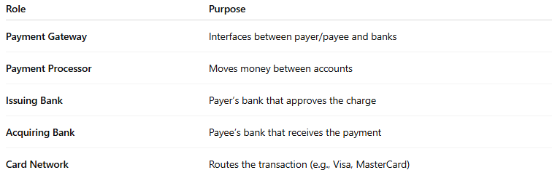
Role | Purpose
Payment Gateway | Interfaces between payer/payee and banks
Payment Processor | Moves money between accounts
Issuing Bank | Payer’s bank that approves the charge
Acquiring Bank | Payee’s bank that receives the payment
Card Network | Routes the transaction (e.g., Visa, MasterCard)

📌 Summary
# Source: AI Source: Provided by: [Data Path: Persons Table -> ID Column: 1, Name_En Column: Motasem Essam] -> From: [ChatGPT] on [1/21/2026]


Term | Definition | Real-World Example
Payer | The one who sends the money | A customer buying from Amazon
Payee | The one who receives the money | Amazon receiving the payment

